

Fellow Golf Enthusiasts:
Thank you for your interest in becoming a member of Hannastown Golf Club.
We believe Hannastown is the best value for private golf in the area. The Club has hosted a wide variety of USGA, WPGA, TRI-STATE PGA, regional & state tournaments, a testament to the consistent quality and conditioning of the golf course. With multiple tee boxes, Hannastown plays enjoyably for all golfers, including juniors and those just picking up the game.
You can choose from affordably priced golf memberships for Families, Individuals and Juniors. Hannastown has a driving range with grass & artificial tees for those members looking to improve their games. The full-length range also provides the opportunity for individual or group lessons. Hannastown Golf Club is a member of the Tri-County Golf Association, a group of area private clubs that provide reciprocal playing privileges to club members. This benefit provides convenient access to other great courses throughout the area!
Golf is at the center of all activities at Hannastown. Optional weekly, handicapped-based tournament events provide competition for those looking for “a game”, and a wide variety of special events mix golf and social opportunities for all members. Hannastown also has a reputation for being the ideal place to bring family, friends or business associates for an enjoyable day of golf and relaxation.
This Membership Packet provides a good feel for the many benefits that come with being a member at Hannastown Golf Club. Feel free to call me directly at the Club or send an email to hannastowngcpro@gmail.com if you have any questions or to arrange a visit. We hope to see you at the club soon!

Shane Rice
PGA Professional
Hannastown Golf Club
724-836-8643 Ext. 1

Visit us at www.hannastowngc.com

Individual (OVer 40): $4,020  Individual (Over 40) Household: $4,920  *individual (Under 40): $3,300  *Individual (UNDER 40) household: $4,080  *individual (AGE 25-29): $2,700  *INdividual (AGE 25-29) Household: $3,300  **Non-resident: $3,300  **Non-resident household: $4,080  ***Junior (Age 14-24): $1,500  ****Social: $2,340  *AGE 25-29 AND UNDER 40  - MUST PRESENT A COPY OF THEIR DRIVERS LICENSE WITH THEIR MEMBERSHIP APPLICATION  **NON-RESIDENT  - MILEAGE IS VERIFIED BY GOOGLE MAPS USING THE SHORTEST ROUTE BY MILEAGE REGARDLESS OF TOLL ROADS. MUST BE 25+ MILES FROM HANNASTOWN GOLF CLUB TO QUALIFY  - DRIVER’S LICENSE MUST BE PRESENTED TO VERIFY MILEAGE ANNUALLY TO BE ACCEPTED AS A MEMBER  ***JUNIOR - RESTRICTED PLAYING PRIVILEGES  - MONDAY - THURSDAY (ALL DAY)  - FRIDAY, SATURDAY, SUNDAY & HOLIDAY - AFTER 2:00PM  ****SOCIAL: RESTRICTED PLAYING PRIVILEGES  - 54 HOLES OF GOLF PER MONTH  - CLUB EVENTS COUNT TOWARD YOUR 54 HOLES  (GREEN FEES & CART FEES MUST BE PAID)  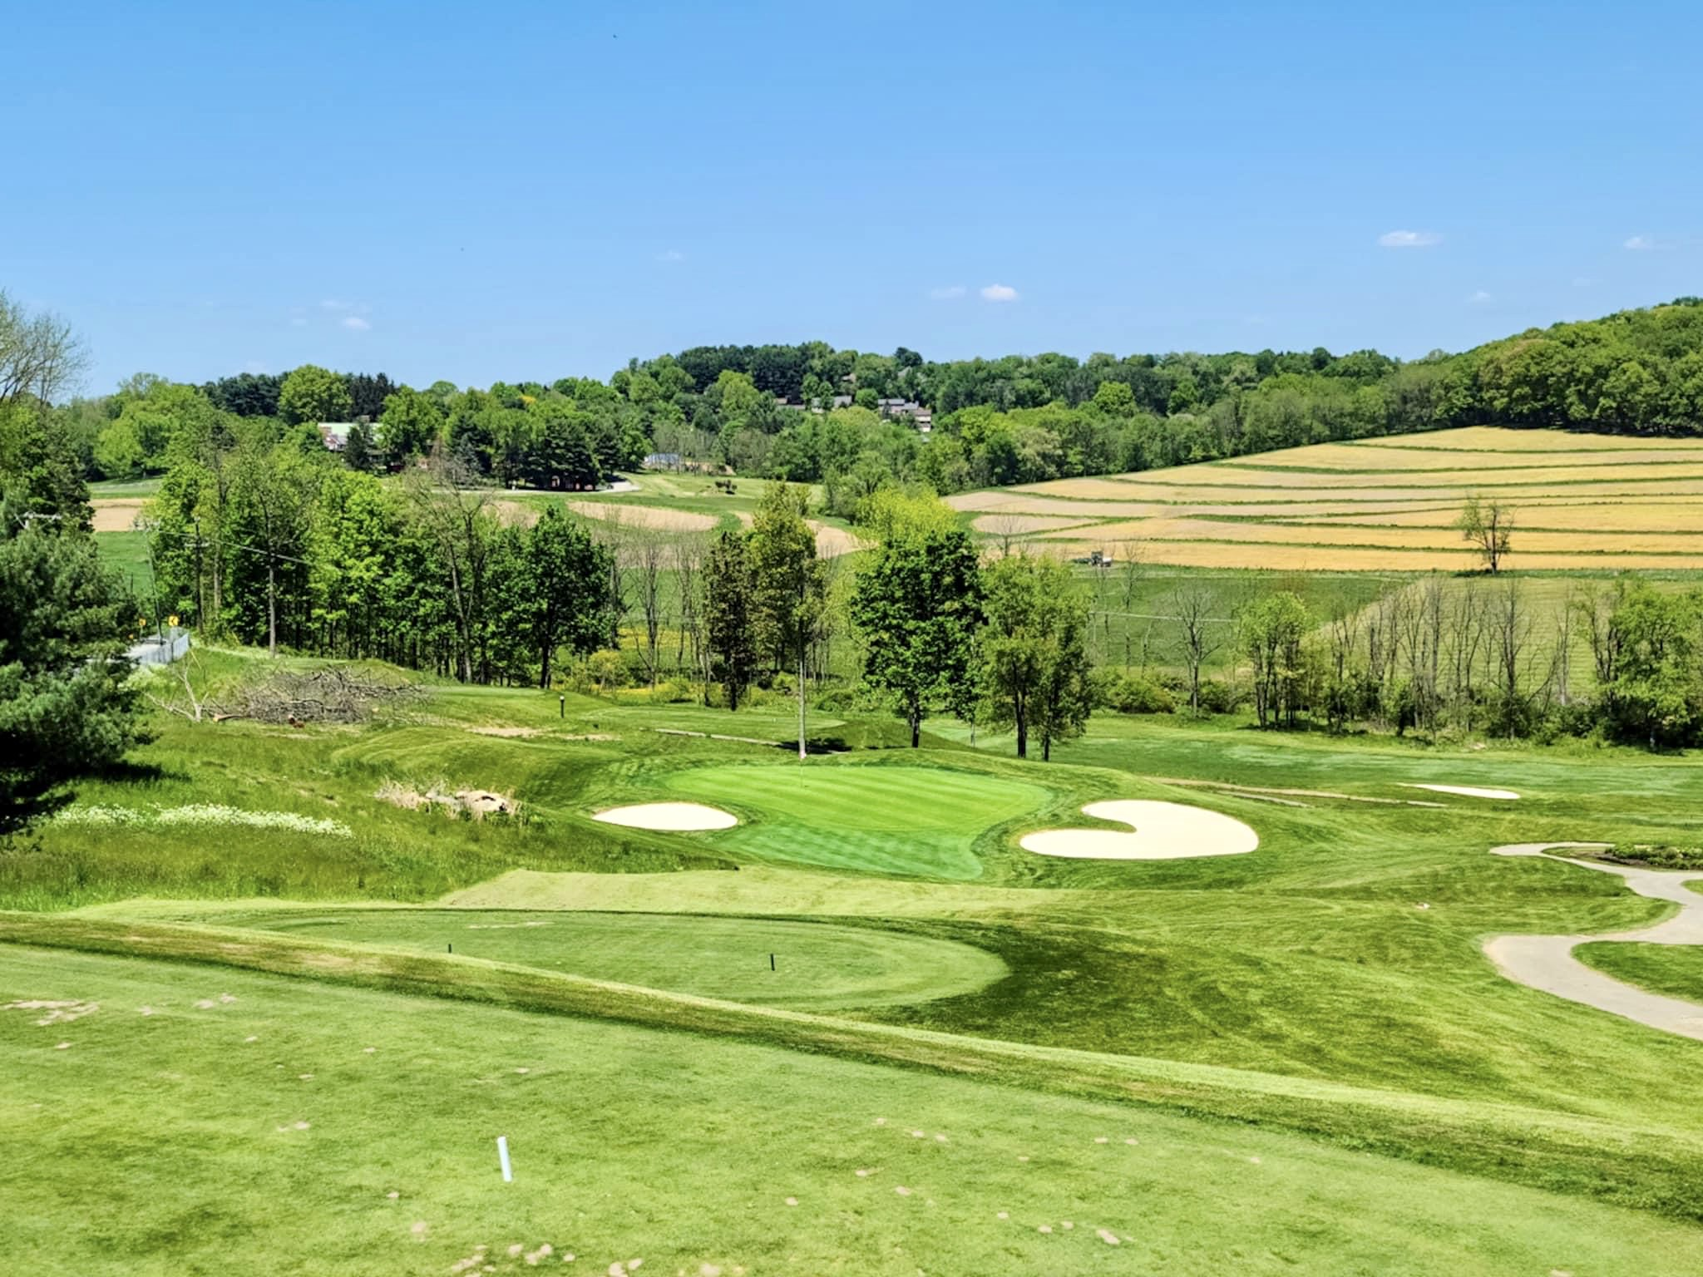  Multiple payment options available including monthly payment plans.  Please inquire at the golf shop
  ALL HANNASTOWN GOLF CLUB MEMBERSHIPS FEATURE:
  DRIVING RANGE ACCESS
  MULTIPLE BILLING OPTIONS
  Hannastown G.C.
  441 Blank School Rd.
  Greensburg, PA 15601
  724-836-8643
  www.hannastowngc.com

AS A MEMBER-OWNED CLUB, HANNASTOWN GOLF CLUB HAS LONG BEEN THE AREA’S BEST VALUE IN PRIVATE GOLF. TODAY, WE’RE MAKING IT EASY AND AFFORDABLE FOR YOU TO ENJOY THE BENEFITS OF MEMBERSHIP. HERE ARE JUST A FEW REASONS YOU SHOULD CONSIDER BECOMING PART OF THE HANNASTOWN FAMILY:  AFFORDABLE:  AFFORDABLY PRICED MEMBERSHIP OPTIONS FOR INDIVIDUALS, HOUSEHOLDS, AND JUNIORS WITH FLEXIBLE PAYMENT PLANS  OWNERSHIP CERTIFICATES AVAILABLE FOR $1,200 (payment plans available)  (CERTIFICATE GIVES YOU VOTING PRIVILEGES WITHIN THE CLUB)  CONVENIENT:  EASY ACCESS TO TEE TIMES UTILIZING OUR ONLINE TEE SHEET, PLAY WHEN IT’S CONVENIENT FOR YOU  MEMBERSHIPS INCLUDE THE GHIN HANDICAPPING SYSTEM TO BE ELIGIBLE FOR CLUB EVENTS  FULLY-STOCKED GOLF SHOP WITH THE LATEST GOLF BALLS, CLUBS AND APPAREL  ALL THE AMENITIES YOU WOULD EXPECT FROM A PRIVATE CLUB, INCLUDING LOCKERS, SHOWERS, FULL BAR AND RESTAURANT  FUN:  A VARIETY OF FUN AND COMPETITIVE GOLF EVENTS FOR ALL SKILL LEVELS  MEMBER-MEMBER, MEMBER-GUEST & SEVERAL OTHER SPECIAL EVENTS THROUGHOUT THE YEAR  GROUP, INDIVIDUAL AND JUNIOR GOLF LESSONS AND CLINICS  OUTSTANDING FOOD AND BEVERAGES AT REASONABLE PRICES, THAT INCLUDE DAILY SPECIALS.  OUTSTANDING COURSE CONDITIONS:  6 SETS OF TEES RANGING FROM 5,000 TO 6,700 YARDS  BENT/POA ANNUA GRASS TEES AND GREENS THAT PLAY SMOOTH AND CONSISTENT  A 300+-YARD DRIVING RANGE SO YOU CAN WORK ON EVERY SHOT IN YOUR BAG  LARGE PRACTICE GREEN TO GROOVE YOUR PUTTING STROKE  ON-SITE PGA PROFESSIONAL AND GOLF OPERATIONS STAFF AT YOUR SERVICE  18 HOLES OF CHAMPIONSHIP GOLF...EASY ACCESS TO TEE TIMES...  AN OUTSTANDING PRACTICE FACILITY…UNLIMITED GOLF AND SOCIAL OPPORTUNITIES... HANNASTOWN REALLY IS ALL ABOUT  FANTASTIC GOLF AND FUN TIMES!  VISIT US ONLINE AT WWW.HANNASTOWNGC.COM
  DRIVING RANGE w/ GRASS TEES
  FULLY STOCKED PRO-SHOP
  ELECTRIC GOLF CARTS
  Hannastown G.C.
  441 Blank School Rd.
  Greensburg, PA 15601
  724-836-8643
  www.hannastowngc.com
Hannastown Golf Club Membership Application
Applicant Information
Last Name: ___________________________
First Name: ___________________________ Date of Birth: _________________________
Cell Phone: ________________________ Email: _______________________________________
Home Address:
_______________________________________________________________________________
Street City State Zip
Please list all other golfers on the membership:
Name________________________________ Date of Birth_____________________________
Name________________________________ Date of Birth_____________________________
Name________________________________ Date of Birth_____________________________

Type of Membership Selected: _______________________________ Driving Range: Yes ____ No____
Past Golf Course Affiliations: ___________________________________________________________
GHIN # ______________________________

Reference or Member sponsor: ________________________ Phone: _____________________
Reference or Member sponsor: ________________________ Phone: _____________________

Applicant’s Signature: ________________________________ Date: ___________________________

CLUB USE ONLY:
Membership Committee sponsor: ___________________________ Signature: ______________________
Membership Committee sponsor: ___________________________ Signature: ______________________

Date Received: ___________ Amount Received: ___________ Date Contacted/Approved: _________
***All non-resident memberships must provide a copy of your driver’s license***

